The Wankel Gokarts comes
The company Wankel Wankel-Rotary presented a small series of KKM Gokarts. Oh with Mid west in England one already manufactured prototypes.
- The Wankel Rotary Kart in the application
- Mid west Wankel Kart in Canada tested
- Back to the NSU Wankel start page
- Back to the GEGE NSU Startseite

Wankel Rotary Gokart
The company Wankel Wankel-Rotary modified and for to boom-end the Gokart operation reequipped their a disks aircraft engine. Came out a Kart of the upper class, both from the performance and from the cost price.
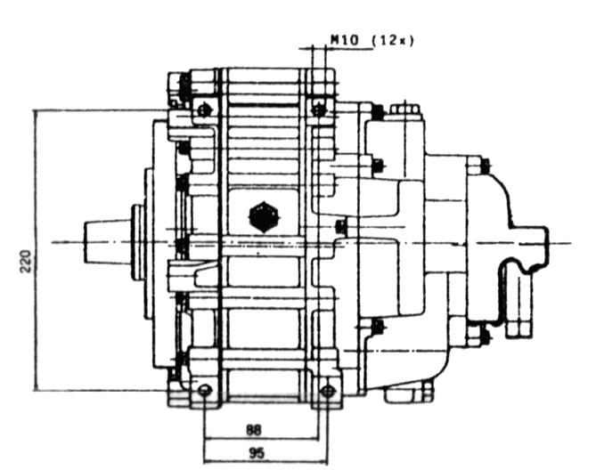
With the Kartmotor it concerns itself around 407 cm ³ an engine with side inlet and mixture-cooled rotor. Housings and eccentric shaft are held by a water cooling system with laterally radiator which is beside the driver bearable temperatures.
The normal engine of the type LCR-407 SG/W carries 41 HP out (30KW) with 6900 min ⁻¹ . The max. torque is with 50 Nm and results when 4500 revolutions per minute. The whole force package weighs thereby, however without exhaust and radiator, only 26 kg. The unit with a fuel oil mixture of 1:70 is lubricated. As oil a full-synthetic engine oil is used. The engine is roll-stored complete and needs no additional oil filling. With the operation of the engine nothing is to be seen and smelled by a typical flagflag flag. The mixture preparation takes over a Bing carburetor type 84/30/115. The NGK candle (type CR8EK) with a hallgebergesteuerten Bosch TSZ/H single ignition is ignited.

Driving impressions
If one made oneself comfortable it with protective clothing and helmet on the Kart, or which one calls in such a way perforce during the tight fit in the seat, it can go loosely. One starts with a normal ignition key, like with the auto. On the impact the electrical starter help the engine to the life. Even, round no-load operation adjusts immediately. Now are to be only controlled gas and brake pedal as well as the pulling steering element. Gear shift and clutch gibtx27s here not. The basic translation is selected over the selection of the gear wheels of the driving chain between the centrifugal clutch and the rigid, differentialless rear axle.
With the gas give gehts equivalent powerfully loosely. The centrifugal clutch accesses clean and sets the driving machine in motion. To a slow round on the Slalomkurs in Leese it goes to the thing. The engine turns without murren lively in the entire speed range. I do not create it to turn the admissible area off up to 6900 ^{min} -1. Was it because of me or was simply only too kurvig the distance???
Apparent the steering element is probably only to holds there, because giving in at that 15 cm steering wheel artet to the Schwerstarbeit for levers and wrists out. Much more easily it goes with the accelerotor pedal, whereby one can achieve a controlled breaking out of the tail. But until I control, I certainly still another few Nachhilfestunden need. This pool Kart, then is called probably the class, was output-prepared only with a rear disc brake, but a silver sister model had also in front two brake disks.
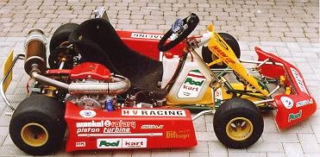
Acceleration is simple also without adjustable transmission brachial. The distance races to formula at one vobei as with pictures of 1 running on the television. With its 41 HP the Kart is certainly also one, at the best motorized. Who would like to have still somewhat specially steam, that can get a unit fine-processed by Wankel Rotary, which delivers over 50 HP also. (details see under the technical data)
The chassis used in the Vorfuehrkart originates from the company HV HV-Racing from Friedrichshafen (Tel. 07541/371600), is particularly for 4-takt Karts sketched from 32 mm steel tube, it has hoehenverstellbare axles, in front adjustable fall and track and a three-way stored rear axle with 40 mm an axle. The chassis weighs, however without engine and tire 53 kg. The whole fun is probably to be received for the price of a brand-new small car, whereby the engine in accordance with Wankel Rotary price list from April 98 with 9976 DM, which chassis depending upon execution with at least 4500 DM and the operation strikes over one season, hopefully without larger damage with still times at least 5000 DM to beech. No quite cheap pleasure thus, but so far is everything in the prototype stage. The high-combed Zweitakter of the current leading vehicles must be reviediert spaetestends after each second running complex, the Wankel is problem-free the whole season without intermediate overhaul to hold out.
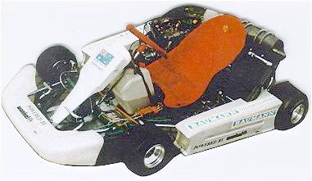

Technical data
Wankel 4-Takt-Kartmotor STANDARD
Model STANDARD Kartmotor: | LCR 407 SG/K
Design of the 4-Taktmotors: | A a piston motorcA piston motor with carburetor
Compression ratio: | 9,5: 1
Chamber volume: | 407 cm3
Performance at number of revolutions: | 30 KW / 41 HP with 6800 min-1, dynamically
Torque at number of revolutions: | 50 Nm with 4000 min-1, dynamically
Dimensions over everything:
L x B x H | 400 mm x 490 mm x 265 mm
Mass: | 26 kg
(engine with carburetor and air cleaner)
Fuel oil mixture: | Regular grade fuel, lead free (RON 92), mixture 1: 70
Lubrication: | self-lubricating, full-synthetic engine oil,
Specification API-TC, mixing proportion 1: 70
Cooling: | Housing and eccentric shaft water-cooled, runners
mixture-cooled
Storage: | completely roll-stored, mixture-lubricated
Starter: | Start over external starter and adaptor piece
Carburetor: | Bing 84/30/115
Ignition system: | Bosch TSZ/H single ignition
Spark plug: | NGK CR8EK

Wankel 4-Takt Race Kartmotor
Model RACE Kartmotor: | LCR 407 SG/KR
Design of the 4-Taktmotors: | A a piston motorcA piston motor with carburetor
Compression ratio: | 9,5: 1
Chamber volume: | 407 cm3
Performance at number of revolutions: | 40 KW / 54 HP with 7000 min-1, (not on test stand measurably)
Torque at number of revolutions: | 60 Nm with 4000 min-1, (not on test stand measurably)
Dimensions over everything:
L x B x H | 400 mm x approx. 550 mm x 265 mm
Mass: (engine with carburetor and air cleaner) | 26 kg
Fuel oil mixture: | Regular grade fuel, lead free (RON 91), mixture 1: 60
Lubrication: | self-lubricating, full-synthetic engine oil,
 | Specification API-TC, mixing proportion 1: 60
Cooling: | Housing and eccentric shaft water-cooled,
Runner | mixture-cooled (only during recovery phase)
Storage: | completely roll-stored,  mixture-lubricated (only during recovery phase)
Starter: | Start over external starter and adaptor piece
Carburetor: | Bing 84/30/115
Ignition system: | Bosch TSZ/H single ignition
Spark plug: | NGK CR8EK
One finds further information on the Wankel Rotary homepage under http://www.wankel rotary.com

- back to the start of page

Midwest Gokart prototype
Midwest discovered in the meantime also the Kartszene. On the North American market they equipped in Canada a there domestic Kartmodell with ueberrollkaefig with a modified a disk wankel engine. It concerns a modifzierten aircraft engine of the type MWE AE50, which a chamber volume of 294 cm ³ has and in the standard design at short notice 50 HP with with 7500 min ⁻¹ carries out as continuous number of revolutions is in the airplane 6700 revolution/min certified. In order the Kart some reserves to win to give, some modifications were made to be able to turn the engine up to ¹⁰⁰⁰⁰ min -1. Also European Gokart manufacturers are to have been interested in the engine.
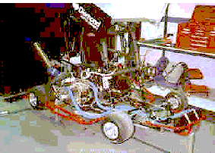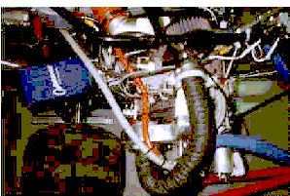
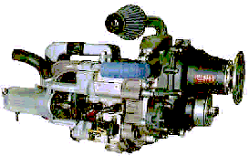As starting point the AE serves 50 engine
The Mid west GAE 50 R for Ultra (Micro)Lights, Homebuilt or kit plan and for your Certified aircraft
TYPE GAE 50
Certification to of JAR - 22 available
Type Wankel - type rotary, Spark ignition
DISPLACEMENT 1 x 294 cc's
Max take off power UP to of 50 BHP (depend on application, please ask for details)
Compression ratio 9: 1
Cooling system
Housing - 50: 50 Distilled Water / Ethylene Glycol mix with integral centrifugal pump
Rotor - air - belt driven centrifugal fan with inlet filter thermistor output available for monitorings coolant
temperature
Net Dry Weight (with gearbox) 33 kg (without optionally components)
Direction OF rotation Clockwise - looking towards the prop. flange face (with gearbox)
Fuel system
Fuel Pressure From aircraft RK 4,5 p.s.i
- Carburettor Tillotson diaphragm type
- type AVGAS 100 LL (Premium 94 RON)
Generator max. 18 Amps, 14 V (brushless, flywheel mounted)
Gearbox Integrated helical gears including torsional vibration more damper
Ratio 1: 0.310
Starter engine Electric 0,6 BHP, 12 V
Lubrication total loss via metering pump from separate tank.
Oil type Silkolene Comp 2 (others AR available soon)
Propeller Flange 127 mm O.D. with
- 6 equally spaced 8 mm holes on 100 P.C.D.
- 6 equally spaced 8 mm holes on 79.4 P.C.D.
- 6 equally spaced 8 mm holes on 75 P.C.D.SAE 1
Ignition system Duplicated C.D. with 2 plugs/rotor, Triggered by inductive unit sensing edge OF flywheel
Mounting Crankcase or mirror-image that
Engine performance datas measured RK static sea level ratings more under the following conditions:
Internationally standard Atmospheric conditions RK sea level, Accessories unloaded, Coolant outlet temp.
65°C(± 5°C), air box fitted, 20.0 " RAM of pipes, power measured RK prop. flange, Either Approved fuel
Optionally extra Vacuum pump Intake air box and Preheat air valve
To supplied by customer oils tank, instrument, Fuel pumps, filter & primer radiator - size depends on
set UP, Silencer
MWE reserve the right to amend the specification without notice

Some information gibtx27s on the Midwest Internetseite under http://www.avnet.co.uk/midwestengines/kart.htm

- back to the start of page

Gerhard Geiling
Original with http://www.home.t online.de/home/geiling /......
ggkart.htm, verse. 1,0 of 26.12.98

